Psychology notes year 12- 2016  
  
**Memory**- an active system that receives information from the senses, organises and alters information, and stores it to be retrieved from storage when needed.

Memory systems- (Atkinson & Shiffrin, 1968)  
**encoding-** information is changed from raw sensory data into a usable form for processing. Information is encoded visually, acoustically and semantically.   
**storage-** retention of information in the brain’s neural pathways.  
**retrieval-** information is taken out of storage when needed.

Memory is simply made up of interconnecting subsystems and goes through 3 stages:  
-sensory memory  
-short term memory/working memory  
-long term memory

Atkinson & Shiffrin multistore model:

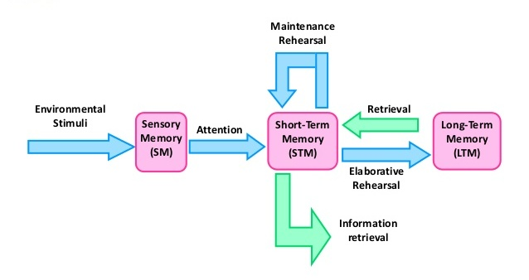 **sensory memory-** we are unconscious of what enters sensory memory   
**-capacity-** large  
**-encoding-** echoic (sound), and iconic(visual)  
**-duration-** echoic- lost after 1/3 second, and iconic- lost after 3-4 seconds   
information in the sensory memory is meaningless unless transferred into short term memory, through selective attention

**Short term memory/working memory-** conscious of what enters   
**-capacity-** small (7 +/- 2 items, Miller, 1956)  
**-encoding-** acoustically   
**-duration-** 18-30 seconds if not rehearsed

**-maintenance rehearsal-** remembering information for immediate use  
i.e. remembering a telephone number   
**-elaborative rehearsal-** actively process and encode information into the long term memory by focusing on the meaning of information and linking it to pre-existing information in long term memory  
 **self-reference effect-** we are more likely to remember information if we can relate new information to personal experiences

Working memory model- Baddeley & Hitch- 4 subsystems to working memory   
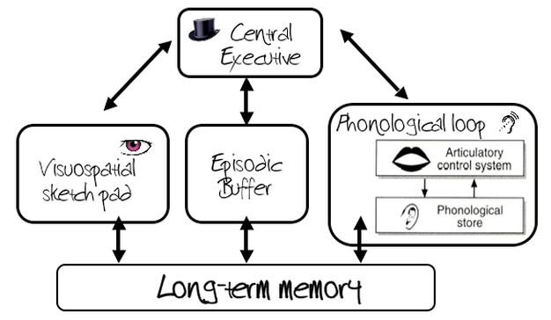

**-Central executive-** coordinated activities between other systems ad allocates attention and cognitive efforts, but does not store the information   
**-Episodic Buffer-** temporary store and integrates information between phonological loop, visuospatial sketchpad and long term memory  
**-Phonological loop-** stores a limited amount of words s information is kept active through sub-vocal rehearsal  
**-Visuospatial sketchpad-** stores visual and spatial information needed for mental imagery and spatial reasoning.  
i.e. knowing what a pig is/identifying it and being able to imagine what it looks like when not directly looking at it

**Consolidation Theory-** information that is transferred from working memory to long term memory needs consolidation time.   
-neurons in the brain change physically when introduced to new information (a new memory is formed)  
-time required is 30 minutes and if information I interrupted then it may be lost or stored incorrectly.

**Long term memory-** information is retained indefinitely but some may be difficult to retrieve   
**-capacity-** very large   
**-encoding-** semantically   
**-duration**- permanent   
**1. Procedural-** ‘how to’ of memory (learnt skills and actions/mainly motor) and does not require conscious effort to retrieve information (most resistant to forgetting)—also known as implicit memory  
i.e. riding a bike  
**2. Declarative-** ‘what’ of memory (facts, information, experiences) and requires conscious effort to retrieve—also known as explicit memory  
i.e. remembering the name of the first American president  
declarative memory can be separated into 2 sub memory systems:   
**-semantic-** meaning and impersonal facts  
i.e. name of the first American president  
**-episodic-** time & place and personally significant events (linked to feelings and sensations)  
i.e. name of first gf/bf

**Interaction between working memory and long term memory  
-serial position effect-** the effect of an item’s positioning in a list, on how well it is recalled. In a long list, the first and last items are remembered best in a long list  
 **-primacy effect-** first items receive more rehearsal and are more likely transferred into long term memory and retrieved easily  
 **-recency effect-** last items are remembered due to still being present in working memory

**Recall-** when we are asked to retrieve information without any prompts or cues   
**Recognition-** identifying information from a list of alternative answers (i.e. multiple choice questions)  
**Relearning-** if we can learn something better the second time round, it must have been retained the first time learning it.   
**Forgetting-** we forget for a number of reasons:  
**-retrieval failure-** inability to retrieve a piece of information  
**-interference-** difficulty to retrieve due to similar information being stored  
 **-retroactive interference-** learning new information interferes with old information   
 **-proactive interference-** old information interferes with learning new information  
**-motivated forgetting-** inability to retrieve information due to the advantage of not remembering it  
 -not deliberate and is purely for self-protection  
**-decay-** fading of memory over time and is more evident in short term memory than long term memory

**Enhancing retrieval   
- organising information and linking it to other information-** this assists storage and retrieval  
**-contextual cues-**specific circumstance or situation that cues or solicits a desired response  
**-emotional state-** material learned in one mood is better remembered in the same mood/state.  
**-Chunking-** grouping of information (i.e. grouping telephone number into a number of groups that allows us to easily remember the number rather than remembering each single digit.)  
**-mnemonics and acronyms**

**Semantic network theory-** the systematic organisation of information in the long term memory in a network of overlapping nodes   
- each node is linked to other nodes and the activation of one node activates many more nodes   
-the more nodes that are activated, the quicker the information is retrieved.

**Learning**- learning results in a change in behaviour that occurs as a result of experience   
-early theorists described it as a behaviour change to a stimulus (stimulus-response theories: Classical Conditioning and Operant Conditioning)  
-later theorists defined it as humans making sense of the world around them (Observational Learning)  
-learning is a result of external changes (environment) and internal processes (cognition)

**Classical Conditioning-** learning that occurs through repeated association of 2 or more stimuli. The learning only occurs when a stimulus produces a consistent reaction.

**Pavlov’s dogs**

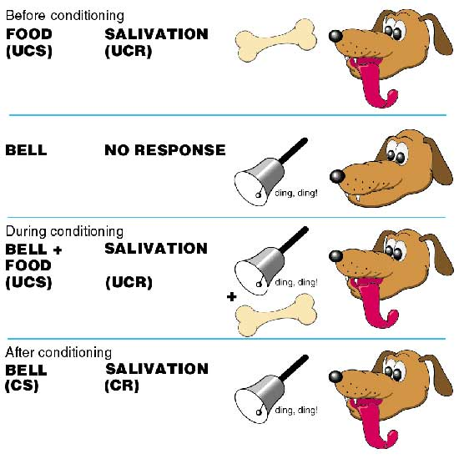**Before conditioning:  
-Unconditioned stimulus-** produces a particularly naturally occurring and automated response (i.e. dog food)  
**-Unconditioned response**- naturally occurring response when stimulus is present (i.e. dog’s reflexive and involuntary salivation response to unconditioned stimulus)  
**During conditioning:  
-Conditioned stimulus-** stimulus that is initially neutral and when associated with an unconditioned stimulus, a similar unconditioned response is produced (i.e. ringing of the bell)  
**After conditioning:**  
**-Conditioned response-** learned response produced by conditioned stimulus that occurs after the conditioned stimulus is associated with the unconditioned response (i.e. dog salivates when bell is heard)

**Little Albert experiment**  
-Watson believed that all individual differences in behaviour were due to different experiences of learning  
-Little Albert was a 9-month-old infant who was tested on his reactions to various stimuli. He was shown a white rat, a rabbit, a monkey and various masks. Albert described as "on the whole stolid and unemotional" showed no fear of any of these stimuli. However, what did startle him and cause him to be afraid was if a hammer was struck against a steel bar behind his head. The sudden loud noise would cause "little Albert to burst into tears. Watson then presented the rabbit only to create a loud noise behind his head. These 2 stimuli became paired repeatedly until little Albert burst into tears at the sight of the rabbit and attempted to crawl away. In this way, Watson believed he could use Classical Conditioning in humans to create phobias.

**-Applications of Classical Conditioning**  
 **-Aversian Therapy**- inhibit/discourage an unwanted behaviour by pairing a response with something undesirable

**Operant Conditioning-** learning behaviour is explained by consequences and reinforcement rather than due to external stimuli

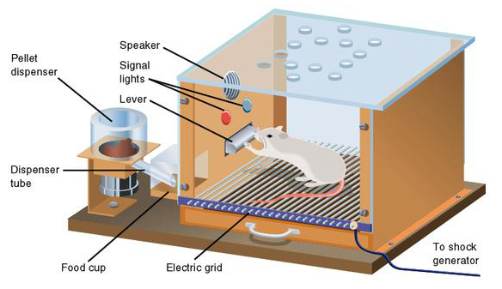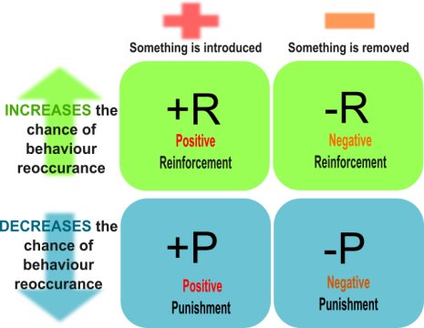-B.F Skinner based his theory off of Thorndike’s law of effect, and introduced reinforcement into the theory: behaviour that is reinforced is repeated and behaviour that is not reinforced occurs less frequently.   
Skinner (1948) studied operant conditioning by conducting experiments using animals which he placed in a 'Skinner Box' which was similar to Thorndike’s puzzle box.

B.F. Skinner (1938) coined the term operant conditioning; it means roughly changing of behaviour by the use of reinforcement which is given after the desired response. Skinner identified three types of responses or operant that can follow behaviour. The positive reinforcer in the Skinner box was the food lever. Every time the rat accidentally pressed the lever, resulting in food being presented, it would increase the rat’s behaviour of pressing the lever. The negative reinforcer occurred as every time the rat would press a different lever, an electric shock would be administered providing some discomfort to the rat. This was to decrease the behaviour of pulling the lever. Punishments are to remove something to

**-Limitations**  
 -operant conditioning fails to take into account the role of inherited and cognitive factors in learning, and thus is an incomplete explanation of the learning process in humans and animals.  
 -The use of animal research in operant conditioning studies also raises the issue of extrapolation. Some psychologists argue we cannot generalize from studies on animals to humans as their anatomy and physiology is different from humans, and they cannot think about their experiences and invoke reason, patience, and memory or self-comfort.

**Acquisition-** referred to as the overall learning process/acquiring behaviour

**Extinction-** gradual decrease in behaviour as the stimulus/reinforcer decreases

**Spontaneous recovery-** extinction might not be permanent and behaviour might recover once again  
**Stimulus generalisation-** occurs when similar stimuli trigger the same response or when a similar behaviour is triggered

**Stimulus discrimination-** behaviour is specific only to the stimuli or reinforcer

Observational learning (Albert Bandura)- most skills are learned and behaviours modified through watching the behaviour of others, which can occur concurrently or vicariously. This takes place as a result of watching others and copying their behaviour or after watching the consequence/awarding of the behaviour of others.

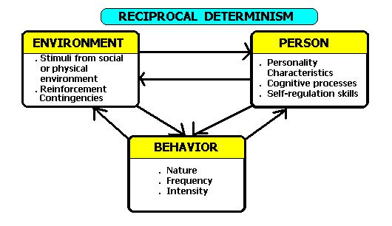**Reciprocal determinism-** a person's behaviour both influences and is influenced by personal factors and the social environment. Bandura accepts the possibility of an individual's behaviour being conditioned through the use of consequences.

**Elements of learning:**  
**-attention**- learner must pay attention to the model  
**-memory**-learner must retain memory of what was learned/observed to store it as a meaningful whole  
**-imitation**-learner must be capable of reproducing the behaviour  
**-motivation and reinforcement**-learner must be motivated to reproduce the behaviour  
 **-external reinforcement-** learning by consequence/reinforcement  
 **-vicarious reinforcement**- reinforcement of other people  
 **-internal/self-reinforcement**- reinforced by personal goals and motivations

**Limitations**  
-Cannot adequately account for how we develop a whole range of behaviour including thoughts and feelings. We have a lot of cognitive control over our behaviour and just because we have had experiences of violence does not mean we have to reproduce such behaviour.  
-It is limiting to describe behaviour solely in terms of either nature or nurture, and attempts to do this underestimate the complexity of human behaviour. It is more likely that behaviour is due to an interaction between nature (biology) and nurture (environment).

**Modifying behaviour**   
**-token economies**- artificial system that will reinforce a target behaviour  
 -symbolic system where primary rewards are provided for consistent good behaviour   
 -later traded for secondary reward, although a certain amount of ‘tokens’ must be accumulated first  
 -rewards cannot be taken away as a punishment  
**Advantage-** individual won’t become bored  
**Disadvantage-** behaviour may not be maintained in outside environment

-**Systematic desensitisation**- uses classical conditioning to remove a person’s phobia/fear  
 -therapist must identify the extent of the phobia  
 -must identify the reason for the phobia  
 -must identify how much it is interfering with daily life  
**Steps:**  
1. Make a list of least fear-provoking to most fear-provoking

2. Teach relaxation techniques to the individual  
3. Exposure to least fear-provoking

4. Repeat until individual is relaxed when exposed to least fear provoking

5. Graded exposure from least fear provoking to most fear provoking, continuously reinforcing relaxation techniques until the person is relaxed when exposed to the most fear provoking.

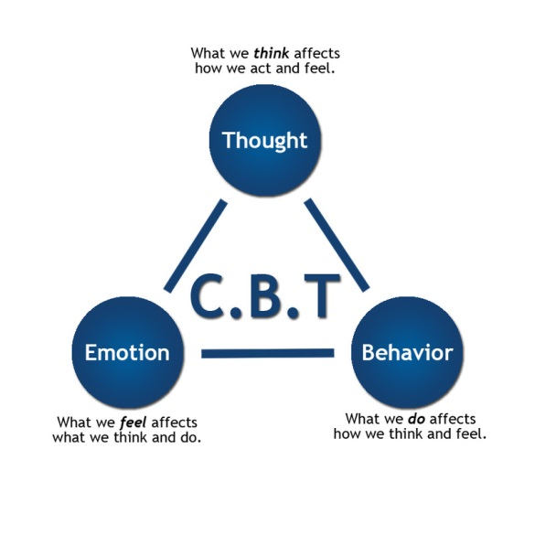**-Cognitive Behavioural Therapy (CBT)-** modify dysfunctional thoughts/cognitions, feelings and behaviours. This type of therapy is used for mental illnesses like anxiety, depression and schizophrenia, and is used in conjunction with medication. This reduces the chance of relapses.

**Steps:**

1. Identify and change negative thinking associated with depressed feelings (view situation from another perspective)
2. Help to focus on positive things (increase fun in life to help overcome depressive cycle)
3. Help to manage problems (give strategies to manage problems specific to the situation)

**Language Development**

-3 types of knowledge children must acquire:  
 **-content-** what to say  
 -**form-** how to say it  
 -**use**

**Spoken language** requires discrimination and production of sounds of language  
**sign language** requires discrimination and production of hand shapes to form signs   
-a 12 month old will use single words  
-a 2 year old will begin to combine 2 words

-at 3 years, a toddler will form complete sentences, although the form is different

-a small child will know how to use appropriate forms when speaking to others, based on their levels of understanding. Short and simpler sentences are used when communicating with a younger child or a child of the same age. When speaking to an adult, the child will tend to be more polite and use more complex language.

Language Acquisition Device (LAD)- Noam Chomsky (1968)

-Chomsky invented the “Black box” called the LAD, and accounts for the innate predisposition to learn language.   
-Chomsky proposed that every child was born with a LAD that holds the fundamental rules for language. In other words, children are born with an understanding of the rules of language; they simply need to acquire the vocabulary.

-Chomsky offered a number of pieces of evidence to support his theory. He posed that language is fundamentally similar across all of humanity. For instance, every language has something that is like a noun and a verb, and every language has the ability to make things positive or negative. He called this the **deep structure rules**.

-Chomsky also discovered that when children are learning to speak, they don't make the errors you would expect. For instance, children seem to understand that all sentences should have the structure 'subject-verb-object', even before they are able to speak in full sentences. From his experiments, Dr. Chomsky also noted that young children, well before reaching language fluency, would notice if adults around them spoke in a grammatically incorrect manner. He also found that children attempt to apply grammatical rules to words for which their language makes an exception. This, he called the **surface structure rules,** where children would eventually learn to peak grammatically correct without correction.

**Limitations**

-pays little attention to our social environment

Jerome Bruner- Language Acquisition Support System (LASS)

-language development occurs through their parents, mainly the mother, guide and support their child’s emerging language.

-LASS consist of the child component- innate propensity to learn language, as well as the adult component, who provides the structural frameworks to facilitate learning language. In this way, LAD requires LASS, and LASS requires LAD.

**Scaffolding-** instruction in the form of framework that encourages learning where the mother stays one step ahead of her child at all times and pushes the child beyond his/her capabilities (teaching WHAT things are)

**Reference-** how people manage and direct each other’s attention by linguistic means (teaching WHERE things are)

**Joint attention-** mother and child pay attention to each other. New objects are introduced by the mother and talk is encouraged. Primitive vocal turn talking (the mother asks a question, the child responds with a noise and the mother responds correspondingly). The mother introduces new objects, like books, in which the mother and child continue to interact on the basis of communicating regarding the object. As the child’s language emerges, the ‘bar is raised,’ in which the interaction between the mother and child becomes like ‘teacher and student,’ and the mother becomes more strict about the responses that she desires to ensure the child’s language emerges correctly.

**Conflict**

-2 parties with incompatible goals, ideas or behaviours experience conflict

-individuals’ needs are not being met

-potentially destructive to relationships

-**Mirror image perception-** each party forms a reciprocal/distorted perception of the other as incorrect and based attributions are made (I’m right, you’re wrong).

**Solutions**

1. **Imposed-** handed down by a person in authority or a third party. The underlying conflict remains unresolved.
2. **Distributive-** involves a compromise or mutual concession where individuals address the demands rater than understanding underlying motives
3. **Integrative-** is a win-win solution where both parties benefit and understand motives, goals and values rather than just addressing the demands

**Techniques**

1. **Counselling-** solves issues in families and allows them to resolve their own conflict as well as teaches conflict resolution skills like listening and assertive communication
2. **Negotiation-** parties have some shared and some opposing interests, and they come together to reach an agreement. It is successful if parties recognise common interests and use them to form the basis of the solution. If successful, it leads to an integrative solution.
3. **Mediation/arbitration-** involves a third party   
    **mediators-** involves a voluntary agreement leading to a distributive or integrative solution   
    **arbitrators-** hand down decisions after listening to both parties leading to an imposed solution

**Parenting styles**

**Socialisation-** a lifelong process during which we learn about social expectations and how to interact with other people. The process of learning influences behaviour, beliefs and actions and starts as soon as we are born.

**Agents of socialisation-** factors that affect the socialisation process (parents/parenting styles, attachment, friends, family, teachers, etc.).

Diana Baumrind- parenting styles

-followed children who had been experiencing different styles of parenting

**Parenting styles:**

1. **Authoritarian-** a parent who relies on coercive techniques to discipline their child, and displays low level of nurturance while doing so. The parent sets firm limits and controls on the child. Along with this, there is little verbal exchange between the parent and child, so the child does not understand as to why the parent sets firm and controlling limits.   
    **-coercive techniques-** threats or physical punishments   
    **-effects on the child-** lack of social responsibility and independence, anxious about social comparison, does not initiate social activity, poor communication skills, unhappiness, boys tend to be more aggressive, and girls are more dependent  
    **-effects on adolescence-** less advanced moral reasoning, less pro-social behaviour, lower self- esteem, poor adjustment to starting school.
2. **Permissive-** parent sets few limits and demands on child’s mature behaviour and allows the child to make own decisions on routine behaviour (bath time, bed time, etc.). This type of parent is either moderately nurturing or completely uninvolved. Sometimes parent can be uninvolved in which the child is rejected and parent has no time for the child. No limits are set and no behaviours are enforced, and no interest is shown in the child. This can be termed, neglectful parenting.   
    **-effects on child-** does not exhibit strong social responsibility or sense of independence, low self- control, low self-reliance, tendency to have high expectations of getting their own way.
3. **Authoritative-** this is the best type of parenting as the parent sets limits on the child’s behaviour using reasoning and explanation. The parent expects their child to behave in a mature manner, uses rewards more than punishments, communicates expectations so the child understands, listens to what the child has to say which encourages dialogue between parent and child, and a high degree of nurturing is involved.   
    **-Effects on child-** child is self-reliant and independent, socially responsible, friendly with peers, cooperative with adults, energetic, achievement orientated, and has a high degree of self-control.  
    **-Effects on adolescence-** more pro-social behaviour, fewer problemmed behaviours, greater academic achievement, and higher self-confidence.

**Attachment**

-defined as the strong emotional tie between a mother and her baby, which is a complex an ongoing process

-Two-way experience  
-requires closeness and responsiveness (mother must consistently respond positively)

-the theory of attachment these strong affectionate ties influence a baby’s mental, social and emotional development which is vital to healthy development.

Harry Harlow (1959)

-was interested in finding out whether provision of food or contact comfort is more important in the formation of infant-mother attachment

-he believed that emotional bonds were important for subsequent healthy development

**-participants-** 8 newborn rhesus monkeys separated from their mothers directly after birth

**-procedure-** group 1-4 isolated in cages where a cloth surrogate mother provided food and wire surrogate did not. Group 2- 4 isolated in cages where a wire surrogate mother provided food and a cloth surrogate mother did not.  
**-results-** all monkeys in groups 1 and 2 spent more time with the cloth surrogate tan with the wire surrogate, regardless of which one provided food.

-**conclusion-** conact comfort is more important in the formation of the infant-mother attachment

Bowlby (1969)

-believed that a mother and her infant are predisposed to for a biological attachment

-babies are born equipped with behaviours that help ensure the parents will love them, stay with them and meet their needs.

**Stages:**

1. **Pre attachment (birth-6 months)-** baby’s innate signals attract caregiver and caregiver remains close when baby responds positively.
2. **Attachment in the making (6-8 months)-** sense of trust is developed tat caregiver will respond when signalled. Infant responds more positively to a more familiar caregiver, but does not protest when separated from parent.
3. **Clear cute attachment (6-8—18-24 months)-** baby displays separation anxiety and protests when parent leaves.
4. **Formation of reciprocal relationships (18months-24 years)-** toddler understands that parent will return.

**Factors affecting early attachment**

1. **Quality of caregiving**- overall sensitivity to infant’s basic needs, responsiveness to basic signals and play in which caregiver encourages ongoing development
2. **Infant characteristics**- temperament, special needs, prematurity, illness
3. **Family circumstances**- stress can undermine attachment
4. **Parent’s internal working model**- parent’s own attachment experiences, and their ability to accept their past

**Maternal deprivation-** separation from or loss of mother as well as failure to form an attachment

**Long term consequences-** delinquency (criminal activity), reduced intelligence, increased aggression, depression, affectionless psychopathy (inability to show affection or concern for others)

-Bowlby’s maternal deprivation hypothesis is supported by Harlow’s research- monkeys reared isolation from their mother suffered emotional and social problems later on. They grew up to be aggressive and struggled to interact with other monkeys.

Ainsworth (1970)

-types of attachments formed between mother and her infant

-Strange Situation scenario

**-participants-** 100 infants aged 12-18 months from middle class American families

**-procedure**

-observation of infant behaviour in a series of 3, 7 minute episodes  
 1. Parent and infant alone  
 2. Stranger joins parent and infant  
 3. Parent leaves infant and stranger alone  
 4. Parent returns and stranger leaves  
 5. Parent leaves infant completely alone  
 6. Stranger returns   
 7. Parent returns and stranger leaves

**-results-** 3 types of attachments were established:

1. **Anxious-avoidant-** in the strange situation, the infants:  
 -will show no signs of distress when parent leaves  
 -are okay with the strange present and will interact with the stranger  
 -will show little interest when parent returns

2**. Anxious resistant-** in the strange situation, infants:  
 -are intensely distressed when caregiver leaves   
 -will avoid and show fear of stranger  
 -will approach caregiver when they return but will resist contact, and may even push them away  
**-Disorganised-** emerged after the study was done and infants with this type show inconsistent behaviour

3. **Secure-** in the strange situation, the infants:  
 -are distressed when parent leaves  
 -will avoid the stranger when left alone but is friendly when parent/caregiver is present  
 -positive and happy when caregiver returns

**Secure children:**

-use mother as safe base to explore environment

-seek attachment in times of distress

-easily soothed by attachment figure

-develop a positive working model of themselves and view themselves as worthy of respect

-mental representation of others as helpful

**Internal working model:**

-framework of feelings, thoughts, goals, motivations and values

-how we view ourselves and others

Culture and attachment:

-Sagi et al (1985)- in Israel, infants who slept with their parents displayed higher percentage of secure attachments compared to infants who slept in a collective sleeping arrangement (Kibbutz). Most insecure attachments showed higher levels of anxious-avoidant attachments.

-Durkin (1995)- in Japan, caregivers are rarely apart from their children. Children initially are unwilling to leave the caregiver to explore in the strange situation experiment.

**Communication**

**Communication styles-** cultural and social aspects of language as well as gender differences in communication

-the way we speak depends on our culture, geographical location, age, sex, generation, socio-economic status, parents and upbringing.

Bernstein (1971)

-relationship between language and social class

-people from lower working class used different language codes to those of middle/upper class

-how language reflects and shapes characteristics of a social group

**Restricted code:**

-used by lower working class people

-relied on preserving traditional roles and ways of interacted and is therefore ‘restricted.’

-Bernstein considered that working lower class people had a language deficit as they did not use elaborated code

**Elaborated code:**

-used by middle/upper class people

-ideas developed in relation to their own experiences and were elaborated in their interactions

-abstract ideas are communicated

Labov (1970)

-contradicted Berstein’s language deficit position

-based his theory on working with black children from New York who used Black English Vernacular (BEV)

-proposed that BEV is just as complex and rule-governed as Standard English

-BEV is to be considered different not deficient

-as linguists, we are unanimous in condemning this view as bad observation, bad theory and bad practice. This is because prejudices still exist (Malcolm and his colleagues, 2008), Indigenous children forced to speak Standard English. Malcolm pointed out the importance of understanding and respecting differences.

Deborah Tannen (1990)

-gender differences in communication styles

-**report talk-** used by men (same style used as in public speaking), to exchange information with little emotional import, to gain and hold the attention of others (centre stage position), and to negotiate and maintain status.

-**rapport talk-** used by women to promote social affiliation and establish emotional connections/relationships, in which they develop understanding, and negotiate differences and share experiences.

-friction occurs between men and women due to the lack of understanding of their differences

Features of persuasive communication

**Persuasion-** trying to change the beliefs, feelings and behaviour of another person or group of people.

Petty and Cacioppo (1986)- 2 routes to persuasion

1. **Central route to persuasion**- individual undergoes thoughtful consideration of the content. **Central processing** occurs when the receiver has the motivation and ability to think about the message and its content before deciding whether they agree/disagree. In this way, they weigh out the pros/cons before agreeing/disagreeing.
2. **Peripheral route to persuasion-** listener decides to agree/disagree based on cues rather than content. **Peripheral cues** occur when the source appears to be an expert or attractive. This is the short cut which allows little direction of cognitive efforts.

Smith and Shaffer (1995)- source of the message, nature of the message and characteristics of the audience

**Source of the message-** individual is more likely persuaded by expertise without assessing the validity of claims; as well as physical attraction, similarity to us, smiling and eye contact. Fast speakers are assumed to be more intelligent and knowledgeable and so are trusted by receivers.

**Nature of message-** when people understand the message, they are more likely persuaded by it. Messages aim to evoke emotional responses so that it allows for interaction and reaction with them, resulting in high chance of persuasion. Similarly, people are more likely to be persuaded by messages that inform on danger, evoking fear. They are also more likely persuaded when informed on benefits and rewards.

**Characteristics of the audience-** age, gender, similarity to us, personality, level of education, culture, capability of taking desired action, enough time and resources to take desired action and level of need for cognition.

**Developmental Psychology**

**Cognitive Development**

Piaget

-concerned about how children learn rather than ability to distinguish right from wrong

**Stages:**

1. **Sensori-motor (birth-2 years)**  
    -babies develop understanding of the world through sensory and motor interactions (mouthing, touching, looking, listening)  
    **object permanence-** ‘object ceases to exist if they are not in sight.’ At 8 months, they understand that an object continues to exist even when it is out of sight.
2. **Pre-operational (2-7 years)**

-ability to speak and print words, memory and imagination develops, and learn that symbols represent something else (STOP sign means stop)  
 **reverse thinking-** thinking that is not often logical and the simple process of reversal cannot yet be processed  
 **egocentricism-** child is only aware of own needs, wants, likes/dislikes and cannot see other’s perspective/confuses perspective of authority with one’s own.

1. **Concrete operational (7-11 years)**  
    -ability to do simple math and measurement, think logically, understand cause and effect, ability to think about concrete things in systematic ways but cannot understand abstract concepts, and are no longer egocentric  
    **seriation-** ability to organise elements into series of ascending/descending order  
    **classification-** ability to construct categories and subcategories of objects  
    **conservation-** amount, weight, volume, number, etc., stays the same even when outward appearance changes  
    **reversibility-** action can be undone/reverted to its previous state
2. **Formal operational (11+ years)**  
    -ability to think and reason logically using abstract terms, question previously accepted hypotheses, can talk about honesty and morality, the possible outcomes of actions can be discussed without having to experience them   
    **Schema-** cognitive structures that organise perceptions and experiences   
    **Assimilation-** we take in new information or experiences and incorporate them into our existing ideas.  
    **Accommodation-** when new information or experiences cause you to modify your existing schemas. Rather than make the new information fit into an existing schema, you change the schema in order to accommodate the new information.

Assimilation + accommodation = LEARNING

**Limitations and criticisms:**

-underestimation of young minds  
-failure to distinguish between competence and performance  
-insufficient attention given to social influence on performance

Seagrim and Lendon (1980)  
-comparison of cognitive performance of children from Aranda and Loritja people, reared in the isolated Lutheran Mission Station in Central Australia, with Indigenous children in other locations in different circumstances.   
**-results-** only children totally immersed in white culture were as capable as white children, other simply lagged  
**-conclusion-** formal schooling plays a vital role in the development of the types of thinking as described by Piaget

Donaldson (1978)- egocentricism   
- when unfamiliar situations that test for egocentricity (mountain activity) was replaced with a familiar one (hiding from the police man), even every young child could carry out the task.

Siegai (1991)- conservation  
-young children’s apparent inability to conserve can be explained by adults breaking conversational rules that children hold. The experimenter does this by repeating the question.  
-children may then become unsure, thinking they have given the wrong answer, and change their answer.   
-if the way the question is asked is changed, there is evidence that children show understanding of the conservation at an earlier stage.

**Social influences**  
-critics argue not enough emphasis was played on the roles of social influence on cognitive development

-may have been wrong about the ages of each stage, but was correct about the sequence in which they occurred

**Moral Development**

Kohlberg (1981)  
-universal sequence to the development of morality  
-6 stages based on children’s responses to various moral dilemmas  
-based responses on Heinz dilemma

**Stages:**

1. **Pre-conventional: punishment & obedience (egocentric) (early childhood)** -does not recognise different points of view and confuses perspectives of authority with one’s own  
    -Heinz should not steal because he will go to prison
2. **Pre-conventional: individual, instrumental and concrete (late childhood)** -aware of different interests and that these may conflict  
    -instrumental exchange of services, goodwill and fairness  
    -Hein should steal because he will be happy to save his wife even if it means she will go to jail
3. **Conventional: mutual, interpersonal expectations, conformity & relationships (early adolescence)** -follows the rules and lives up the expectations of others and maintaining trust, gratitude, respect and loyalty  
    -Heinz should steal because his wife expects it
4. **Conventional: social system and maintenance of one’s conscience (late adolescence)**   
    -doing one’s duty and taking the view of the system—obeying laws and upholding social order  
    -Heinz should not steal because the law prohibits stealing
5. **Post-conventional: rights & social contract (early adulthood)** -asserting and integrating basic rights, value and legal contracts—laws=contracts

-a) Heinz should steal because anyone has the right to live  
 -b) Heinz should not steal because everyone has the right to fair compensation

1. **Post-conventional: universal ethical principles & moral point of view (late adulthood)** -commitment to the universal principles of justice and respect for others   
    -a) Heinz should steal because saving human life is more fundamental than property rights of someone else   
    -b) Heinz should not steal because that violates the rule of honesty and respect

**Support theorists:**

Colby et al (1983)  
-evidence for Kohlberg’s theory  
-20 year longitudinal study using original participants  
-stages of moral development occurred in proposed sequence  
-10-16 years stage 1 & 2 decreased while stage 3 & 4 increased  
-10% participants aged 30 at stage 5  
-no evidence for stage 6

Snarey (1985)  
-supports prediction through stages 1-4 (same order & time)  
-stage 5 was more Western cultures that rural or village cultures  
-reflection of Western individualism

**Criticism theories:**

Richard Schewder (1991)  
-Western culture biased

-culture-based study (Hindu orthodox-teacher)—the Indian version of Heinz dilemma  
-Kohlberg’s coding system does not allow a man to take into account the reasoning of a man with a sophisticated understanding of his own culture

Isawa (1992)  
-cross-cultural analysis of Japan and USA  
-similar stages of moral reasoning

-USA participants favoured Heinz stealing to preserve his wife’s life

-Japanese participants thought Heinz should not- to preserve a clean and pure life

Carol Gilligan (1982)  
-gender biased- Kohlberg only used men

-29 American women  
-whether or not to continue a pregnancy—interview based

**-level 1: self-interest**- women justified responses in terms of own needs and wishes  
**-level 2:self-sacrifice**- women argued in terms of the rights of others- referring to the wishes of their partner and their unborn child

**-level 3: care as a universal obligation**- balance between personal wellbeing and care for others

**-Females**- operate at stage 3: interpersonal feelings, relationships and compassion—a morality of care

**-Men**-operate at stage 4 & 5: rules, rights and abstract principles—a morality of justice

Tomlinson- Keasey and Keasey (1974)  
-links between cognitive and moral development

-girls aged 11-12 at stage 5 scored well on tests of abstract reasoning as predicted

-some failed to show stage 5

-abstract reasoning may be a necessary precondition but it is not sufficient explanation of post-conventional moral reasoning

**Identity**

Erik Erickson

**-Identity formation-** development of long-lasting personality characteristics

**-Sense of identity-** understanding of nature of the self as distinct from others in terms of enduring personality characteristics

-studied human development across lifespan and established 8 stages of identity development

-stages were considered a model of personality development

-2 conflicting ideas resolved successfully for a person to become confident and contributing members of society

-failure to master tasks led to feelings of inadequacy

-he did not believe that each stag was needed to move onto the next, although difficulty would be experienced

-based on clinical observations of patients he was treating

**Stages:**

1. **Trust vs mistrust (hope) (0-1 years)-** infant is dependent on others and trust that they will provide. If needs are met consistently, they will develop a sense of trust and feel secure. Failure of needs being met leads to mistrust.
2. **Autonomy vs shame and doubt (will) (1-3 years)-** discovery that they possess many skills and abilities, growing a sense of independence and become autonomous. If successful, it will lead to increased independence, self-control and self-confidence. Overprotection or disapproval leads to shame and doubting of own abilities.
3. **Initiative vs guilt (purpose) (3-6 years)-** social and motor skills develop—balance and wish to achieve more leading to sense of initiative and secure ability to make decisions. Punishments can induce guilt an lead to lack of self-initiative.
4. **Industry vs inferiority (competence) (7-12 years)-** learn to read, write and do sums in which the individual has the need to win approval by demonstrating competencies valued by society. If successful, it will lead to pride in accomplishments. If efforts are messy, the child may feel inferior.
5. **Identity vs role confusion (fidelity) (adolescence)-** re-examining f identity and exploring possibilities to find out who they are. A sense of identity will develop if they adapt and grow into changes. Failure to establish a sense of identity in society leads to role confusion.
6. **Intimacy vs isolation (love) (young adulthood)-** individuals build close relationships and experience love once stable identity is established. Succession leads to seeking intimacy and develops ability to care for others and share experiences. Lack of intimacy will lead to isolation and feelings of being uncared for.
7. **Generativity vs stagnation (adulthood)-** social and cultural activities concerning the welfare of others and society as a whole, as well as caring for children. If successful, individual will feel productive and creative. Failure leads to becoming stagnant and feelings of unproductivity.
8. **Integrity vs despair (wisdom) (late adulthood)-** time of reflection and looking back on life with satisfaction and acceptance. If successful, wisdom will allow sense of closure and completeness when reflecting. Failure leads to dissatisfaction, despair, hopelessness, etc.

**Limitations**

-Erikson does not explicitly explain how the outcome of one psychosocial stage influences personality at a later stage.

-not empirically tested

**Personality**

-defined as the characteristic ways in which a person thinks, feels and behaves, which makes us who we are.

**Temperament-** physical and hereditary parts of personality (sensitivity, emotion, irritability).

-personality is split into 3 theories: trait, humanistic and social cognitive

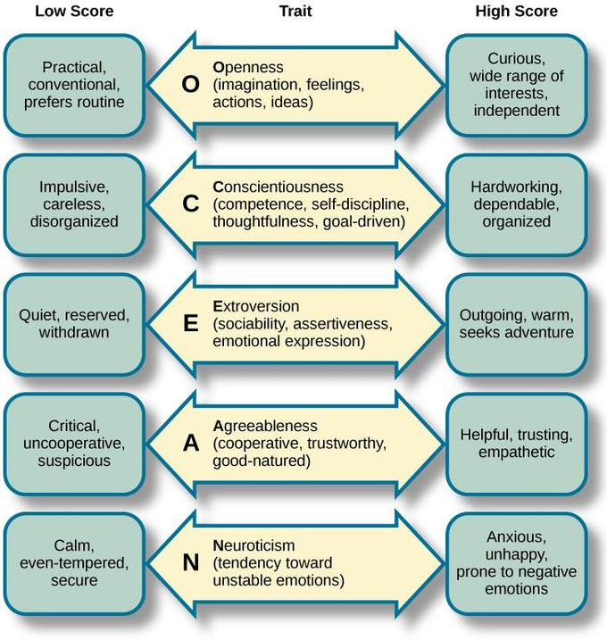Trait theory- McCrae and Costa (1999)

**Traits-** consistent characteristics inferred from behaviour that collectively reflect personality. They are used to predict that individuals behave in similar ways in different circumstances, and are stable and consistent over time. They are relatively independent of each other and vary in degree from person to person.

**Trait theory-** involves identifying and measuring individual personality characteristics. This categorisation gives us a holistic picture of the personality of a person. Trait theory is not concerned with any ‘hidden’ personality dynamics.

Michael Ashton & Lee Kibeom (2007)- added a 6th dimension- honesty—humility.

Helle Pullmann (2006)- consistency & continuity over time

-longitudinal research about Estonian adolescents (12-18 years).

**Rank order stability-** do scores for a trait remain high or low relative to peers even when the group changes?

**Mean level consistency-** changes in mean scores for traits in each group over time

**Individual continuity-** do personality traits of individual participants remain stable over timr?

**-results**  
 -all factors remained stable from ages 12-18

-by age 16, rank order stability remained constant  
 -traits well established by adolescence

**Strengths**  
-useful descriptions of personality and its structure

-led to the development of valid and reliable ways to measure personality

-can be explained why personality is stable and enduring over time

**Criticisms**

-traits identified not as personality but as predispositions

-does not tell us about the nature and development of individual differences

-fails to consider unconscious processes, beliefs and motives that may affect personality

**Limitations**

-4/5 generalise across cultures and countries

-openness to experience is the trait that cannot be generalised as it varies

Humanistic theory- Rogers and Maslow

-humanistic theories emphasise the uniqueness of each individual and positive qualities as well as the potential of all humans

-Sometimes called the **phenomenological approach-** each individual’s unique perception of his/her own world, determining our behaviour and shaping our personality

**Based on 2 assumptions:**

-all people are born good  
 -all people strive to reach their full potential in life

Carl Rogers-

-believed that for people to grow, they required 3 necessary conditions in their environment:

-**genuineness-** genuine/ open and does not put on a front   
 -**acceptance-** prepared to take us as we are regardless of short comings and don’t expect us to change who we are (unconditional positive regard)

-**empathy-** when they try to see things from our perspective and understand how we feel

-Humans have one basic motive- to self-actualise, which is to fulfil one’s potential and achieve highest level of human-being. But to be able to self-actualise, they must reach a state of congruence: a match between ideal self (person we’d most like to be like), self-image (what we think of ourselves), and our true self (who we really are). This is the psychological definition for **self-concept.**

-Rogers used Q-Sort technique (Stephenson, 1953) in 2 ways:

1. Clients given cards and told to organise what they think they are most like to what they think they are least like

2. Given cards and told to organise what individuals would most like to be like to what they would least like to be like

**congruent:** **incongruent:** people like this result to defence mechanisms:  
 -**distortion:** change meaning and **denial:** ignoring and not noticing

Abraham Maslow- Hierarchy of needs   
-he believed that people possess a set of motivational systems unrelated to rewards or conscious desires

-people are motivated to achieve certain needs

-when one need is fulfilled a person seeks to fulfil the next one

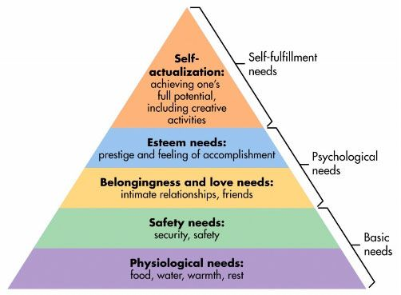-individuals must first have basic needs met before trying to meet a higher one

-Maslow noted only one in a hundred people become fully self-actualized because our society rewards motivation primarily based on esteem, love and other social needs.  
-1. **Biological and Physiological needs** - air, food, drink, shelter, warmth, sex, sleep.  
2. **Safety needs -** protection from elements, security, order, law, stability, freedom from fear.  
3. **Love and belongingness needs -** friendship, intimacy, trust and acceptance, receiving and giving affection and love. Affiliating, being part of a group (family, friends, work).  
4**. Esteem needs -** achievement, mastery, independence, status, dominance, prestige, self-respect, respect from others.  
5. **Self-Actualization needs -** realizing personal potential, self-fulfillment, seeking personal growth and peak experiences.

**-characteristics of a self-actualised person:**

-tuned into reality  
 -at peace with themselves   
 -open and spontaneous  
 -fresh appreciation of the world around them

-sensitive to other’s needs

**Limitations and criticisms:**  
-It could be argued that biographical analysis as a method is extremely subjective as it is based entirely on the opinion of the researcher. Personal opinion is always prone to bias, which reduces the validity of any data obtained. Therefore Maslow's operational definition of self-actualization must not be blindly accepted as scientific fact.

-Furthermore, it is extremely difficult to empirically test Maslow's concept of self-actualization in a way that causal relationships can be established.

-Through examining cultures in which large numbers of people live in poverty (such as India) it is clear that people are still capable of higher order needs such as love and belongingness. However, this should not occur, as according to Maslow, people who have difficulty achieving very basic physiological needs (such as food, shelter etc.) are not capable of meeting higher growth needs.

**Limitations of the humanistic approach:**

-Ignores biology (e.g. testosterone).

-Unscientific – subjective concepts.

E.g. cannot objectively measure self-actualization.

-Humanism ignores the unconscious mind.

-Behaviorism – human and animal behavior can be compared.

-Qualitative data is difficult to compare.

-Ethnocentric (biased towards Western culture).

-Their belief in free will is in opposition to the deterministic laws of science (prevailing evil still in the world)—too optimistic

Social Cognitive theories of personality  
-personality itself does not determine behaviour, it influences behaviour but context must also be taken into account



Albert Bandura- reciprocal determinism  
-interaction between behaviour, cognitive factors and environmental factors

**-environment-** when watching the actions of others and the consequences of those actions, we work our rules and standards that apply to behaviours in certain situations

**-cognition**- conscious goals and standards of our own, influence our thoughts, feelings and actions.

**-self-efficacy-** degree to which a person is sure of their ability to achieve a desired outcome  
 -influences which activities you choose to tackle and how you perform  
 -strong self-efficacy- mastering new skills and meeting challenges in specific situations

**-personal control**  
 -**internal locus of control-** belief that you control your own destiny. Those that have this achieve better at school, act more independently, are healthier, better able to deal with stress, delay gratification and feel less depressed  
 -**external locus of control-** belief that outside forces control your fate

Walter Mischel  
-discovered why people behave differently in different situations  
-people make responses that will lead to a desirable outcome

**Person situation controversy**-when small chunks of behaviour are analysed on a moment to moment basis, situational variables are more influential and behaviour appears to be more variable  
-when large chunk of behaviour are analysed, people tend to be reasonably consistent and personality traits are more influential

-concluded that both the situation and the person are important in determining behaviour.

**Personality signature-** distinctive but stable patterns of “if-then” situation behaviour  
 -if x situation occurs, then y behaviour may result   
**self-regulation-** refers to ability to set and work towards a goal  
**delayed gratification-** denying oneself a reward in the present to get a better reward in the future   
 **marshmallow experiment-** young children differ in their degree of self-control  
 Mischel followed them throughout high school  
 **results-** children with more self-control in preschool (ones that waited for the bigger reward), were more successful in high school as positive relationships developed and were less likely to have substance abuse issues. As adults, they had more stable relationships.   
 -children who had poor self-control in preschool (ones who grabbed and ate the marshmallow straight away) were not successful in high school  
 **conclusion-** people are situation predecessors. Children in the experiment interpreted the reward of the situation in their own way. It stresses the importance of both the situation and the way in which the person perceives the situation. People use cognitive processes to interpret the situation and behave in relation to the situation.

**Strengths of social cognitive theories:**  
-makes us aware of how situations affect behaviour and how behaviour affects the situation  
-scientifically tested

**Limitations and criticisms:**  
-ignores unconscious influences

-ignores emotional influence

**Social Psychology**

-scientific study of nature and causes of individual’s behaviour in social situations

**Group-** when two or more people interacting with each other, influencing each other for more than a few minutes.

**Group polarisation-** when individuals are in groups that hold similar attitudes or beliefs, discussion in the group strengthens beliefs. Individuals tend to make more extreme decisions than that of mean of individual members’ initial positions, in the direction favoured by the mean.

**Reasons for group polarisation:**

**-Persuasive arguments**- people in the group will hear their own arguments but also new ones that support their positions.   
 **-Social comparison**- members shift in direction of group to gain approval and avoid disapproval  
 **-Social identity theory**- produces conformity to group norm. People in the discussion actively gain perception of the group norm, and positions can be polarised away from that of the outgroup.

Stanley Milgram- obedience and compliance   
**obedience-** following the commands of someone with authority or that holds rules/laws of our society  
**compliance-** changing one’s behaviour when requested to do so- not necessarily involving an authority figure

-Milgram was interested in why Nazi SS officers obeyed orders from superior officers to gas millions of Jews during WW2.

**-participants & procedure**  
 -40 males aged 20-50  
 -“randomly” assigned role of teacher- “learners” were confederates of the experimenter  
 -teachers were told to ask a series of questions, and told to administer shocks to learners if they make a mistake- starting at 15V an increasing by 15V up until 450V(death).

-Experimenter continually tells teacher to go on  
 -learners not actually shocked but acted as though they were

**-results**  
 -70% of participants delivered the full voltage of 450V  
 -no one walked out of the experiment   
**-conclusion**  
 -if the person believes the experimenter has legitimate authority and is not responsible for anyone’s harm, they are more likely to obey.

**Factors affecting obedience:**

**-social proximity**- less likely to obey if close to victim and further away from experimenter  
**-legitimacy of authority figure**- more likely to obey if authority figure is seen to have legitimate power

**-group pressure-**more likely to obey if there is no/little group support for disobeying

**Cross-cultural studies:**

-complete obedience (90%+) in Spain and Netherlands, over 80% in Italy, Germany and Austria. Only 40% Australian men obeyed and 16% Australian women.

**Applications:**

-atrocious acts in WW2

-tendency to obey without thinking about consequences

-Medication errors- nurses obeying doctors

-keeping a job regardless of how ‘wrong’ the reason for obedience

-obedience to authority to maintain safety

**Ethics:**

-informed consent- true nature not explained so consent was not informed

-withdrawal rights- not clearly told they were able to withdraw whenever  
-deception

Solomon and Asch (1955)- conformity

**Conformity-** changing one’s behaviour in response to group pressure

Factors affecting conformity:

**-Size of the group-** conformity increases with group size of up to 4 and decreases beyond 4

**-unanimity-** if everyone else agrees, the person is more likely to conform  
**-informational social influence-** watching the behaviour of people around us and conforming due to being unsure of how to behave or what the answer is   
**-normative social influence-** conforming to the group standards to be a part of the group

**-culture-** lower conformity in individualistic cultures and higher conformity in collectivist cultures

**-social loafing-** tendency to make less effort in a group than when on their own. Social loafers conform to the group by exerting less effort.

**-deindividuation-** sense of anonymity that can occur in a group situation—people sometimes shed inhibition to conform to the group engaging in negative behaviour

**-participants and procedure**

-groups of 8-10 people—1 participant, the rest were confederates of the experimenter

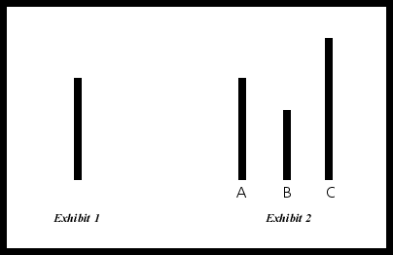 -confederates deliberately told to give the incorrect answer 12/18 times   
**-results**  
 -75% participants agreed with the obviously wrong answer at least once  
 -50% agreed with the wrong answer at least 6 times   
 -less than 1% error in comparison of participants alone

Zimbardo (1973)- power, status and conformity

**Power-** individual/or group’s ability to control or influence the thoughts, feelings or behaviour of another person or group

**Status-** importance of an individual’s position in a group, as perceived by the members of the group

-The aim was to investigate how readily people would conform to the roles of guard and prisoner in a role-playing exercise that simulated prison life.

-Zimbardo (1973) was interested in finding out whether the brutality reported among guards in American prisons was due to the sadistic personalities of the guards (i.e. dispositional) or had more to do with the prison environment (i.e. situational).

**-Participants and procedure:**

-To study the roles people play in prison situations, Zimbardo converted a basement of the Stanford University psychology building into a mock prison. He advertised for students to play the roles of prisoners and guards for a fortnight.

More than 70 applicants answered the ad and were given diagnostic interviews and personality tests to eliminate candidates with psychological problems, medical disabilities, or a history of crime or drug abuse. The study comprised 24 male college students (chosen from 75 volunteers) who were paid $15 per day to take part in the experiment. Participants were randomly assigned to either the role of prisoner or guard in a simulated prison environment. There were 2 reserves and one dropped out, finally leaving 10 prisoners and 11 guards. The guards worked in sets of 3 (being replaced after an 8 hour shift), and the prisoners were housed 3 to a room. There was also a solitary confinement cell for prisoners who 'misbehaved'. The prison simulation was kept as “real life” as possible.

Prisoners were treated like every other criminal, being arrested at their own homes, without warning, and taken to the local police station. They were fingerprinted, photographed and ‘booked’. Then they were blindfolded and driven to the psychology department of Stanford University, where Zimbardo had had the basement set out as a prison, with barred doors and windows, bare walls and small cells. Here the deindividuation process began. When the prisoners arrived at the prison they were stripped naked, deloused, had all their personal possessions removed and locked away, and were given prison clothes and bedding. They were issued a uniform, and referred to by their number only. The use of ID numbers was a way to make prisoners feel anonymous. Each prisoner had to be called only by his ID number and could only refer to him and the other prisoners by number. Their clothes comprised a smock with their number written on it, but no underclothes. They also had a tight nylon cap to cover their hair, and a locked chain around one ankle. All guards were dressed in identical uniforms of khaki, and they carried a whistle around their neck and a billy club borrowed from the police. Guards also wore special sunglasses, to make eye contact with prisoners impossible. Three guards worked shifts of eight hours each (the other guards remained on call). Guards were instructed to do whatever they thought was necessary to maintain law and order in the prison and to command the respect of the prisoners. No physical violence was permitted. Zimbardo observed the behaviour of the prisoners and guards (as a researcher), and also acted as a prison warden.

**Results:**  
 -Within a very short time both guards and prisoners were settling into their new roles, with the guards adopting theirs quickly and easily. Within hours of beginning the experiment some guards began to harass prisoners. They behaved in a brutal and sadistic manner, apparently enjoying it. Other guards joined in, and other prisoners were also tormented. The prisoners soon adopted prisoner-like behaviour too. They talked about prison issues a great deal of the time. They ‘told tales’ on each other to the guards. They started taking the prison rules very seriously, as though they were there for the prisoners’ benefit and infringement would spell disaster for all of them. Some even began siding with the guards against prisoners who did not obey the rules. Over the next few days the relationships between the guards and the prisoners changed, with a change in one leading to a change in the other. Remember that the guards were firmly in control and the prisoners were totally dependent on them. As the prisoners became more dependent, the guards became more derisive towards them. They held the prisoners in contempt and let the prisoners know it. As the guards’ contempt for them grew, the prisoners became more submissive. As the prisoners became more submissive, the guards became more aggressive and assertive. They demanded ever greater obedience from the prisoners. The prisoners were dependent on the guards for everything so tried to find ways to please the guards, such as telling tales on fellow prisoners.  
 -prisoners had to be released after 4 days due to severe negative reactions and the experiment was put to an end after 6 days. Even Zimbardo was conforming to his role, becoming more concerned for the security of the prison than the study itself.  
**Conclusion:**  
 -social roles influence behaviour in more complex ways than ever realised  
 -social environment influences the way individuals behave

Norman Triplett- performance   
-noticed cyclists performed better when racing against each other than when racing against the clock

**Social facilitation-** boost in performance due to presence of others

-only worked or simpler tasks (racing and winding a reel)  
-when doing complex tasks, presence of others leads to worse performance either due to people that are watching (**audience effect**) or people also participating (**coaction effect**)  
**social inhibition-** presence of others reduces performance on a task (complex tasks)

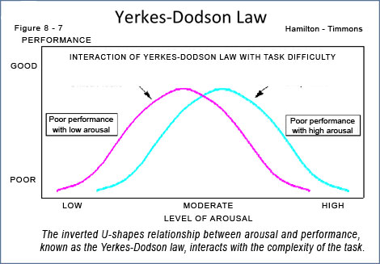Yerkes and Dodson- arousal  
-people generally perform best at moderate levels of arousal depending on the type of task

-simple/well-learned tasks- performance is better at high levels of arousal  
-difficult/new tasks- performance is better at low levels of arousal

-level of arousal increases when being watched and correlates to performance

Leon Festinger (1957)- Cognitive Dissonance

**Cognitive dissonance-** psychological tension between holding 2 beliefs that are in conflict or when they behave in way inconsistent with our beliefs.

-Relationship between cognitions and behaviour   
-people dislike inconsistency and seek to reduce it and find evidence that supports their own view

-when there is a discrepancy between beliefs and behaviours, something must change in order to reduce or eliminate the dissonance.

-the greater the dissonance, the stronger the attempt to reduce it

**-participants and procedure**  
 -college students participated in a series of dull tasks, and after completing the task, half were offered $1 to tell the next participant the task was interesting and would be fun. The other half were paid $20 to do this. Later, all participants were asked to rate how interesting it was.  
**-results**  
 -those paid $1 rated the task as enjoyable whereas those paid $20 rated it as less enjoyable. There was no communication between participants. A small incentive had les individuals to believe that what they had said whereas those paid more had a compensating reason for changing their belief

**-ways to reduce cognitive dissonance:**  
 1. Change the behaviour  
 2. Change the attitude  
 3. Reduce the importance of the conflicting belief  
 4. Focus on more supportive beliefs that outweigh the dissonant belief/behaviour

-Festinger believed people will choose the easiest course of action to reduce dissonance—often meaning changing the attitudes as it is usually easier to change than the behaviour.

Attribution theory  
-how people infer the causes behind the behaviour of others

Heider (1958)

-Believed that people are trying to make sense of the social world   
-based on 3 principles:

1. We tend to look for causes and reasons for others behaviours in order to discover their motives  
 Heider & Simmel (1944)- asked people to describe the movement of abstract geometric shapes. They described them as if they were people with the intention to act in certain ways.

2. We tend to look for stable and enduring properties of the world around us, so we can predict and control the environment.

3. We distinguish between personal factors (internal attribution) and environmental factors (external attributions)

**Internal attributions-** making attributions based on internal traits of others (their personality)  
**External attributions-** making attributions based on environmental factors

**Fundamental attribution error-** the tendency for observers to underestimate the situational influences on behaviour and overestimate the impact of personal characteristics on behaviour. We tend to make external attributions to explain our own behaviour and internal attributions to explain the behaviour of others.   
 Scherer (1978)-found that people made assumptions about the personalities of complete strangers based on hearing their voice on the phone

**Self-serving bias-** making external attributions to maintain our self-esteem

Kelley- Causal Attribution Theory  
-people make attributions based on 3 pieces of information:

1. **Consistency-** degree to which behaviour is the same across time and/or situations
2. **Consensus-** degree to which other people’s behaviours are similar to that of the actor
3. **Distinctiveness-** concerns the extent to which similar stimuli draw the same behaviours from the actors

-in making an attribution, people identify the factor that occurs most often with the behaviour and then say that this is the factor that caused the behaviour

**Cultural differences:**

**-Individualistic**- behaviour reflects one’s personality and attitudes

**-Collectivist**- behaviour reflects social roles and norms

1990s Rogue Trade Scandal:

-American newspapers attributed the mess up to individuals

-Japanese newspapers attributed the mess up to the lack of organisational controls

**Limitations:**

-doesn’t explain why information such as stereotypes affect the intake of information we use to make attributions

-doesn’t explain why some people prefer simple causal explanations over taking into account all of the possible factors

**Cultures and Values**

**Community-** a group of people living together in one place

Gusfield (1975)- suggested there are 2 uses of the term community:

1. **Territorial an geographical-** neighbourhood, town, city
2. **Relational-** “quality of character of human relationships without reference to location”

Vesely, Bloom and Sherlock (2005-

-describe common attributes of learning communities as shared purpose, interaction, boundaries, behaviour, trust and respect

Chapman, Radmondt and Smiley (2006)-

-suggested that a common community included elements such as familiarity, rapport, trust and openness

DiRamio and Wolverton (2006)-

-focused on the definition of online community on student interaction and social activity for collaborative learning

**Sense of community-** a feeling that members belong and matter to one another as well as to the group. They have a shared faith that members needs will be met through their commitment to being together

McMillan and Chavis (1986)- 4 criteria to be met for an individual to feel a sense of community (McMillan and Chavis Model)

1. **Membership-** feeling of belonging or of sharing a sense of personal relatedness   
   components:

**-boundaries-** physical and otherwise (difference between ingroup and outgroup)  
 **-emotional safety-** protection of group intimacy, part of a broader notion of security  
 **-sense of belonging and identification-** fits in the group, belongs there, acceptance by the group, willingness to sacrifice for the group (role of identification: it is my group)  
 **-personal investment-** earned one’s place in the group—investment makes it more meaningful and valuable as a member has worked for the community and feels as though they have earned their membership  
 **-common symbol system-** maintain groups boundaries; value of the symbol by all who use it (dress, fashion, logos)—means of identifying who belongs to the community

1. **Influence-** a sense of mattering, of making a difference to a group and of the group mattering to its members. With this a 2-way relationship exists between a group and its members:  
    1. Members are more attracted to a community in which they feel that they are more influential  
    2. Influence on the community and influence of the community on s member happens at the same time
2. **Integration and fulfilment of needs-** reinforcement and need for fulfilment is a primary function for a strong community. Some of the rewards that are effective reinforcers of communities are status of membership. Individual values are the source of the need (people do what serves their needs). A strong community is able to fit people together so that people meet others needs while they meet their own. It is also dependent on cultures and families.
3. **Shared emotional connection-** features of emotional connection within a community:  
   -contact hypothesis- the more people interact, the closer they become  
   -quality of interaction- the more positive the experience, the greater the bond (there needs to be positive interactions between members)  
   -closure to events- tasks are resolved   
   -shared event hypothesis- crisis  
   -investment- donate time, money and effort  
   -effect of honour and humiliation- reward or humiliation  
   -spiritual bond- intangible connection between members

**Impact of significant events on individuals**-large scale events affect both communities and individuals   
-they can be positive or negative but still cause stress.

**Traumatic events-** unexpected negative events that threaten lives or sense of wellbeing

**Factors that determine whether we find an event stressful:**

1. **Predictability-** unpredictable events are usually more stressful and have a longer lasting effect (Kate and Wykes, 1984)
2. **Controllability-** having no control over an event can increase stress (Geer and Maisel, 1972)
3. **Experiencing threat or loss-** even positive events can be stressful if we feel threatened

**Positive responses:**

Kobasa(1979,1982)- resilience

-longitudinal design with sample of 600 hardy personalities

-personality differences account for different responses to stress (1979)

-people with hardy/resilient personalities are less likely to get ill during times of stress (1982)

-resilience can be learnt by combining challenging situations with enough support to ensure success—we learn that we can deal with something we thought would have found impossible

**Qualities of a resilient person:**

-see change as a challenge

-feel in control of their lives

-sense of direction in their work and personal lives

-capacity for making the most out of small windows of opportunity

-deep rooted faith in a system of meaning

-healthy social support network

-wide comfort zone

**Post-Traumatic Growth-** positive change experienced as a result of struggle with a major life crisis or traumatic event

**-occurs in 5 areas:**   
1. New opportunities opening up possibilities that were not present before

2. Change in relationships with others

3. Increased sense of one’s own strength

4. Greater appreciation for life in general

5. Deepening of spiritual lives and/or significant change in one’s belief system

**Things to remember:**

-people that experience growth also experience suffering—distress is typical

-traumatic events are not implied as good

-post traumatic growth is not universal

**Negative responses**

**Post-Traumatic Stress Disorder (PTSD)-** a person who has experienced, witnessed or has been confronted with an event/s that involved threaten of death or serious injury, or threat to integrity of self or others

-Needs to have involved response of intense fear, helplessness or horror

-Does not occur straight away- onset can trigger it years after it had occurred

**Effects/reactions/symptoms:**

**-Physical-** disturbed sleep, nightmares, exhaustion, restlessness, and headaches

**-Cognitive-** poor concentration, disturbed attention and memory, intrusive thoughts and disorientation

**-Emotional-** fearfulness, avoidance, anxiety, panic, depression, guilt, withdrawal

**-Regression-** young children may regress in their behaviour, bed wet, thumb suck, scared of the dark, and lose trust in adults who were not able to protect them from the event

**Treatment:** therapy and medication are usually combined

**Therapy-** Cognitive Behavioural Therapy or desensitisation

**Medication-** antidepressants

**Impact of significant events on communities**

-vulnerable groups mostly affected

-elderly cope better than young due to life experience and reduced expectations of external help

**-Community resilience**

**-Competent communities-** ones able to identify needs and issues and work cooperatively to carry out plans and achieve goals

-if people live in competent communities and have a strong sense of belonging and attachment to the community, the community is considered to be resilient

-Elliot and Paris (2006)- the black, elderly and poor are most vulnerable

Julie Ann Pooley (2006)- community competence

-Feelings of attachment to a community can lead to an increased sense of self-efficacy and social network, which can lead to reduced stress levels and increased growth—post traumatic growth

**Long-term effects of world events:**

Elder (1974)- children of the Great Depression

-longitudinal study of 167 children- 11-12 years of age

-interested in the physical, psychological and social changes that occurred from childhood to adolescence

-studied specifically the home characteristics, father’s occupation and indictors of levels of living

-findings/effects of Great Depression:

-group suffering deprivation- life achievement was more important than for those who didn’t suffer

-children of working class homes- adult health was negatively correlated to economic hardship

-conservative values developed among the offspring of those who were deprived (importance of marriage, children and job security)

**Biological Influences**

**Nervous System**

**CNS-** consists of the brain and spinal cord

**PNS-** consists of everything else other than the brain and spinal cord. PNS carries sensory impulses from muscles and glands to the CNS, and motor impulses from the CNS to muscles and glands.

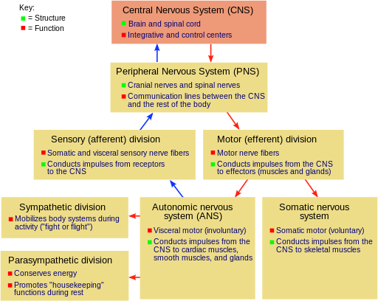**grey matter-** unmyelinated fibres

**white matter-** myelinated fibres

**cerebrum-** consists of convolutions (gyri and sulci) and is responsible for higher order functions

**cerebellum-** fine motor coordination—posture and balance

**brain stem-** medulla oblongata is responsible for lower order functions such as **respiratory centre** which controls rate and depth of breathing, **cardiac centre** responsible for rate and force of heartbeat, and **vasometer centre** responsible for diameter of blood vessels

**forebrain-** consists of thalamus and hypothalamus and controls everything from voluntary movement and the integration of sensory information to all our higher abstract thought, logic, speech, and emotions.

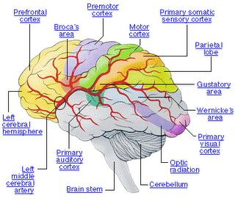**Midbrain-** acts most notably as the information superhighway connecting the forebrain and hindbrain. It enables your brain to integrate sensory information from your eyes and ears with your muscle movements, thereby enabling your body to use this information to make fine adjustments to your movements.

**Hindbrain-** The hindbrain is the region of the brain formed by the pons, medulla oblongata (also known as just the medulla), and the cerebellum. Together, these three structures govern our autonomic, or 'automated' body systems, controlling everything from our heart, breathing, and sleep patterns to our bladder function, sense of equilibrium, and fine motor control.

**Frontal lobe-** planning, problem-solving, thinking, memory, learning, analysing, voluntary movement, emotion

**Broca’s area-** muscles of throat, mouth, jaw, tongue and face. It is responsible for the production of articulate speech, structuring sentences and analysing grammar. **Broca’s aphasia** is in the right frontal lobe and occurs as a result of damage to the Broca’s area and results in the inability to produce clear and articulate speech.

**Parietal lobe-** is responsible for bodily sensations and proprioceptive and tactile functioning.

**Temporal lobe-** is responsible for memory and auditory information. The right temporal is responsible for non-verbal sounds, and the left is responsible for verbal sounds associated with language. The left temporal contains the **Wernicke’s area,** which is responsible for comprehension of speech and formation of meaningful sentences. It is connected to the Broca’s area by the arcuate fasciculus. Damage to this area of the brain results in **Wernicke’s aphasia** which results in the ability to hear and see words but the inability to understand their meaning and resulting in the pronunciation of strings of words that is ungrammatical which makes the speech meaningless.

**Occipital lobe-** it is responsible for visual information, colour, shape, motion, and dimension. Damage to this lobe results in visual impairment.

**Association areas-** integrate information received as stimuli

**Corpus callosum-** connects the left and right hemispheres transferring information between them.

Roger Serry- split brain studies

-specialisation of the left and right hemisphere functions

-the right is responsible for space, perception, music and creativity. It is also responsible for rudimentary words and phrases contributing emotional context to language.

-the left is responsible for analytical and verbal tasks, and for the sequential and mathematical/science tasks.

**Action potentials-** the change in electrical potential associated with the passage of an impulse along the membrane of a muscle cell or nerve cell.

**-resting potential (-70mV)-** inside of the membrane is negatively charged and outside of the membrane is positively charged. It is the name for the electrical state when a neuron is not actively being signalled. A neuron at resting potential has a membrane with established amounts of sodium (Na+) and potassium (K+) ions on either side, leaving the inside of the neuron negatively charged relative to the outside.

Steps:

1. **Depolarization-**A stimulus starts the depolarization of the membrane. Depolarization, also referred to as the "upswing," is caused when positively charged sodium ions rush into a nerve cell. As these positive ions rush in, the membrane of the stimulated cell reverses its polarity so that the outside of the membrane is negative relative to the inside.
2. 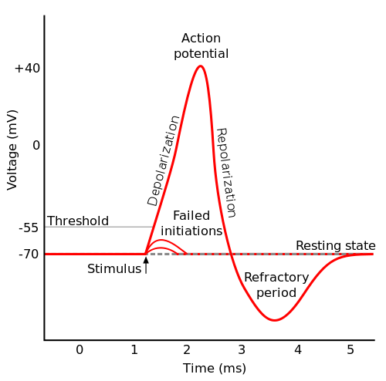**Repolarization-**Once the electric gradient has reached the threshold of excitement, the "downswing" of repolarization begins. The channels that let the positive sodium ion channels through close up, while channels that allow positive potassium ions open, resulting in the release of positively charged potassium ions from the neuron. This expulsion acts to restore the localized negative membrane potential of the cell, bringing it back to its normal voltage.
3. **Refractory Phase**- The refractory phase takes place over a short period of time after the depolarization stage. Shortly after the sodium gates open, they close and go into an inactive conformation. The sodium gates cannot be opened again until the membrane is repolarized to its normal resting potential. The sodium-potassium pump returns sodium ions to the outside and potassium ions to the inside. During the refractory phase this particular area of the nerve cell membrane cannot be depolarized. Therefore, the neuron cannot reach action potential during this "rest period."

**All or none principle-** once threshold is reached, an action potential of a fixed size is fired, and the size is always the same. In saying this, size of the stimulus is not related to strength of the impulse. However, we can tell the difference between strength of stimuli as stronger stimuli activate a larger proportion of nerve fibres. If a neuron does not reach threshold, an action potential is not fired.

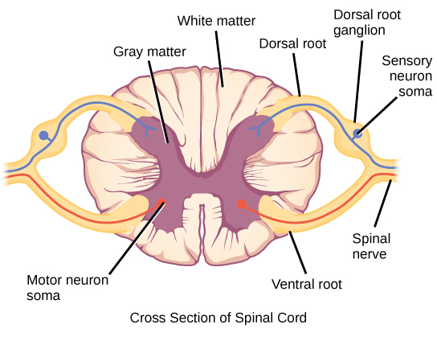

**The spinal cord-** consists of the central canal containing myelinated ascending and descending tracts. **Ascending tracts** are sensory axons that carry impulses towards the CNS. **Descending tracts** are motor axons that carry impulses away from the CNS.

**Central Nervous System neurotransmitters-** dopamine and serotonin

**Peripheral Nervous System neurotransmitters-** acetylcholine and noradrenaline

|  |  |
| --- | --- |
| Somatic Nervous System | Autonomic Nervous System |
| Effectors: skeletal muscles | Effectors: cardiac cells, involuntary muscles and cells |
| One motor neuron from CNS | 2 motor neurons: 1 from parasympathetic, 1 from sympathetic |
| Neurotransmitter are neuromuscular junction: acetylcholine | Neurotransmitter at neuromuscular junction: acetylcholine (rest and digest), or noradrenaline (fight or flight) |

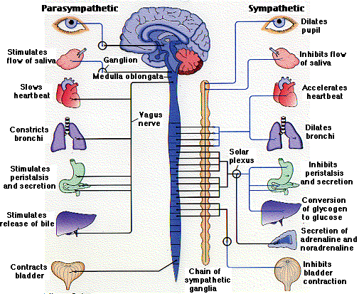

**Reflexes-** an action that is performed without conscious thought as a response to a stimulus.

**Spinal reflex arc-** is the neural pathway that controls an action reflex. In higher animals, most sensory neurons do not pass directly into the brain, but synapse in the spinal cord. This characteristic allows reflex actions to occur relatively quickly by activating spinal motor neurons without the delay of routing signals through the brain, although the brain will receive sensory input while the reflex action occurs. There are two types of reflex arcs: autonomic reflex arc (affecting inner organs) and somatic reflex arc (affecting muscles).

**Neurotransmitters-** a chemical substance which is released at the end of a nerve fibre by the arrival of a nerve impulse and, by diffusing across the synapse or junction, effects the transfer of the impulse to another nerve fibre, a muscle fibre, or some other structure. They act to either increase transmission or decrease transmission.

**Types:**

**-Acetylcholine-** enables muscle action, learning, memory and arouses the PNS. A malfunction, such as an undersupply marks Alzheimer’s disease.

**-Dopamine-** enables movement, learning, attention, emotion and arouses the CNS. A malfunction such as an undersupply can produce tremors and decrease mobility of Parkinson’s disease.

**-Serotonin-** controls mood, hunger, sleep, and arousal and arouses the CNS. An undersupply links to depression.

**-Norepinephrine-** controls alertness and arouses the PNS and CNS. An undersupply can depress mood.

**-GABA-** is an inhibitory transmitter and inhibits the CNS. An undersupply is linked to seizures, tremors and insomnia.

**-Glutamate-** is an excitatory transmitter involved in memory and arouses the CNS. An oversupply can overstimulate the brain producing migraines and seizures.

**Psychoactive drugs-** chemical substances that affect the nervous system and brain activity. They can be classified as recreational or prescription.

1. **Recreational** **-depressants-** ‘downers’-- calm the activity of the nervous system and slow bodily functions  
    **-stimulants-** ‘uppers’—excite the nervous system and arouse bodily functions  
    **-hallucinogens-** change perceptions and give sensory images without sensory input   
   examples:  
    **-alcohol-** is a depressant and decreases focus, reaction and reasoning  
    **-amphetamines-**is a stimulant and increases heart rate, focus, energy and creates euphoria   
    **-caffeine-** is a stimulant and increases heart rate, blood pressure and keeps one awake  
    **-cocaine-** is a stimulant   
    **-ecstasy-** is a stimulant/mild hallucinogen and stimulates thirst which can result in drowning   
    **-heroin/opium-** is a depressant   
    **-ice/methamphetamine-** is a stimulant and increases heart rate  
    **-LSD/ergot fungus-** is a hallucinogen  
    **-marijuana/cannabis-** is a hallucinogen   
    **-nicotine-** is a stimulant and increases heart rate
2. **Prescription**  
    **-anti-depressants-** increased levels of norepinephrine and serotonin at the synapse or inhibits the enzyme that breaks down the neurotransmitters or blocks the reabsorption at the pre-synaptic knob  
    **-anti-psychotics-** work to damp down responses to irrelevant stimuli that cause hallucinations, delusions and disordered thoughts of schizophrenia. They also work to block the synaptic receptors in the brain’s dopamine pathways.